Customer Shopping Behavior Analysis
- Project Overview
This project explores customer shopping behavior based on 3,900 purchase transactions across multiple product categories.
The goal is to extract actionable insights on:
- Spending patterns and customer demographics
- Product and category preferences
- Subscription and loyalty trends
- Discount and shipping behavior
These insights aim to support data-driven marketing, pricing, and retention strategies.
- Dataset Summary
Dataset Size
Rows: 3,900
Columns: 18
Key Features:
Customer Demographics: Age, Gender, Location, Subscription Status
Purchase Details: Item Purchased, Category, Purchase Amount, Season, Size, Color
Shopping Behavior: Discount Applied, Promo Code Used, Previous Purchases, Frequency of Purchases, Review Rating, Shipping Type
Missing Data:
37 missing values in the Review Rating column (≈0.9%)
- Data Preparation & Processing (Python)
Steps Taken
  - Data Loading: Imported using pandas.
Exploration: Used .info() and .describe() for structure and summary statistics.

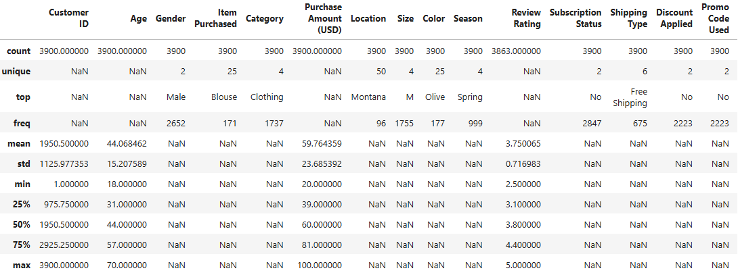
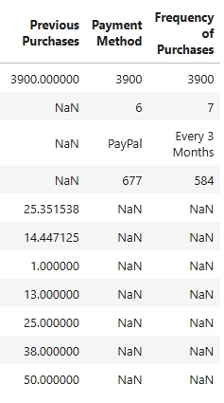
Missing Values: Imputed missing Review Rating values using the median rating per product category.
Standardization: Converted all column names to snake_case for consistency.
Feature Engineering:
Created age_group (e.g., Young Adult, Middle Aged, Senior).
Created purchase_frequency_days to quantify shopping regularity.
Data Consistency Check: Verified if discount_applied and promo_code_used were redundant; dropped promo_code_used.
Database Integration: Cleaned dataset loaded into PostgreSQL for advanced SQL analysis.
- Data Analysis using SQL (Business Transactions)
Revenue by Gender
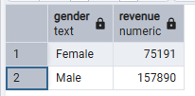
Insight: Males contribute ~68% of total revenue, suggesting either a higher purchase frequency or larger order values.
High-Spending Discount Users
Identified customers who applied discounts but spent above average ($59.76).
Insight: Indicates potential smart bargain hunters who value discounts yet maintain premium spending. These are useful for targeted upselling with coupons.
Top 5 Products by Average Rating
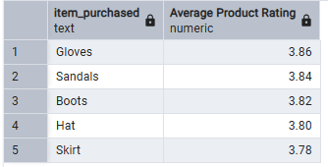
Insight: Accessories and footwear dominate top-rated items. They are ideal for featured listings and promotional highlights.
Shipping Type Comparison
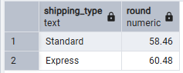
Insight: Customers choosing Express Shipping spend slightly more (+3.5%), possibly indicating higher willingness to pay for convenience.
Subscription Analysis
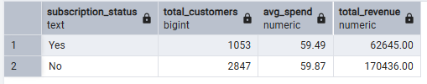
Insight: Subscribers spend about the same per order as non-subscribers, so the revenue gap stems from their smaller numbers, not lower spending power. They represent a loyal core segment worth nurturing through exclusive offers.
Discount-Dependent Products
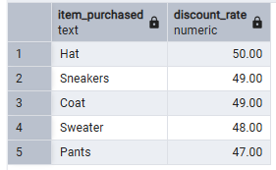
Insight: These items are highly price-sensitive. Consider optimizing discount margins or bundling to protect profitability.
Customer Segmentation (Based on Purchase History)
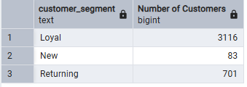
Insight: 80%+ of customers are Loyal, indicating strong retention It’d be beneficial for loyalty program expansion.
Top 3 Products per Category
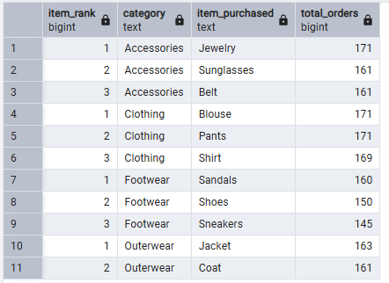
Insight: These drive high category-level sales. Focus marketing efforts on them.
Subscriptions & Repeat Buyers
(Are repeat buyers also subscribers?)
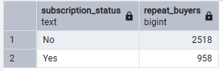
Insight: Roughly 1 in 3 frequent buyers are subscribers, showing opportunity to convert repeat non-subscribers through incentives.
Revenue by Age Group
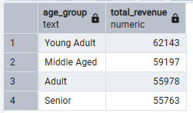
Insight: Younger adults generate the highest revenue, indicating they are the most active and valuable shopping segment, while spending remains relatively consistent across older age groups.
- Customer Behavior Dashboard
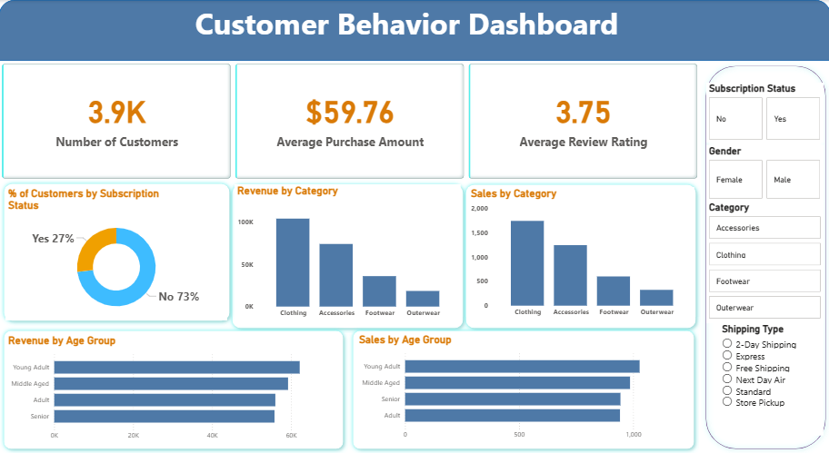
- Business Recommendations
Subscription Growth: Promote exclusive perks such as free express shipping and early access to new collections to encourage more repeat buyers to subscribe.
Loyalty Programs: Introduce tiered rewards for frequent customers to strengthen retention and build brand loyalty.
Discount Optimization: Review high-discount products to ensure promotions remain profitable and margins are protected.
Product Marketing: Highlight top-rated and best-selling products in campaigns to increase conversions and enhance customer trust.
Targeted Campaigns: Personalize marketing efforts for Young Adult customers and Express Shipping users, as these groups show higher engagement and spending potential.
Review Management: Encourage customers to leave more reviews to refine product insights and improve overall credibility.

